**Tasks for Standard Sprint - Property Analysis - Part 1**

**1.Standardize dataset for Suburbs: - Screenshots for all the Suburbs dataset.**

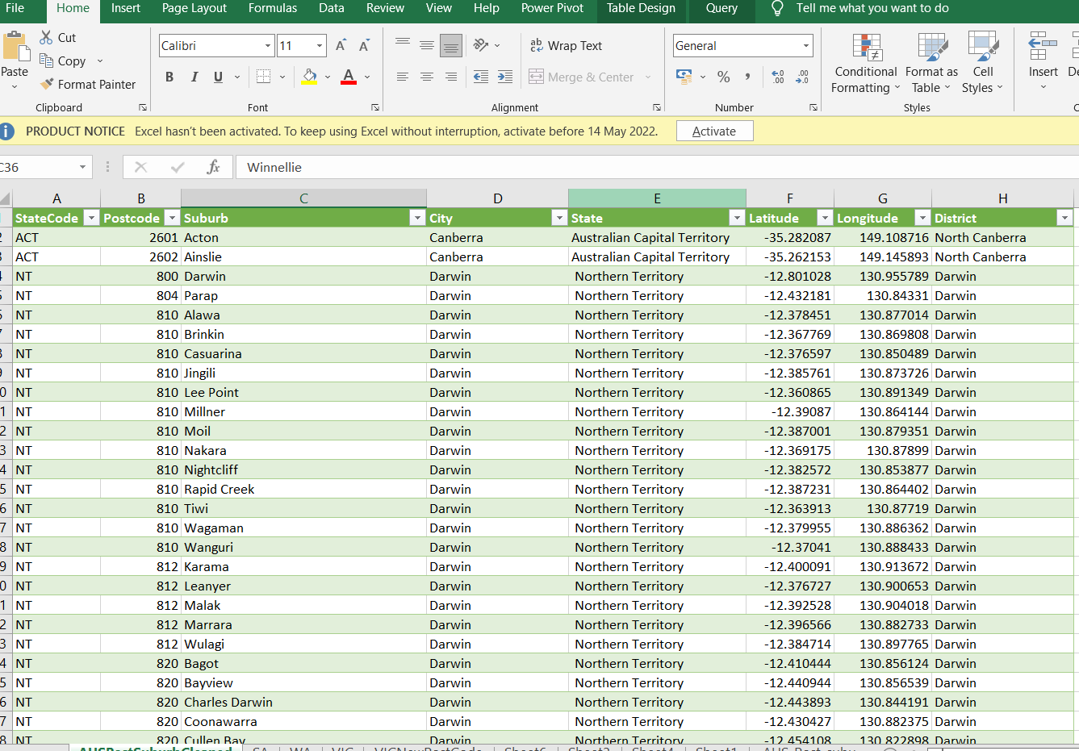

**2. Standardize datasets for Public Transport in Australia: - Below is the Snapshot of ACT, NSW and VIC Transport Dataset**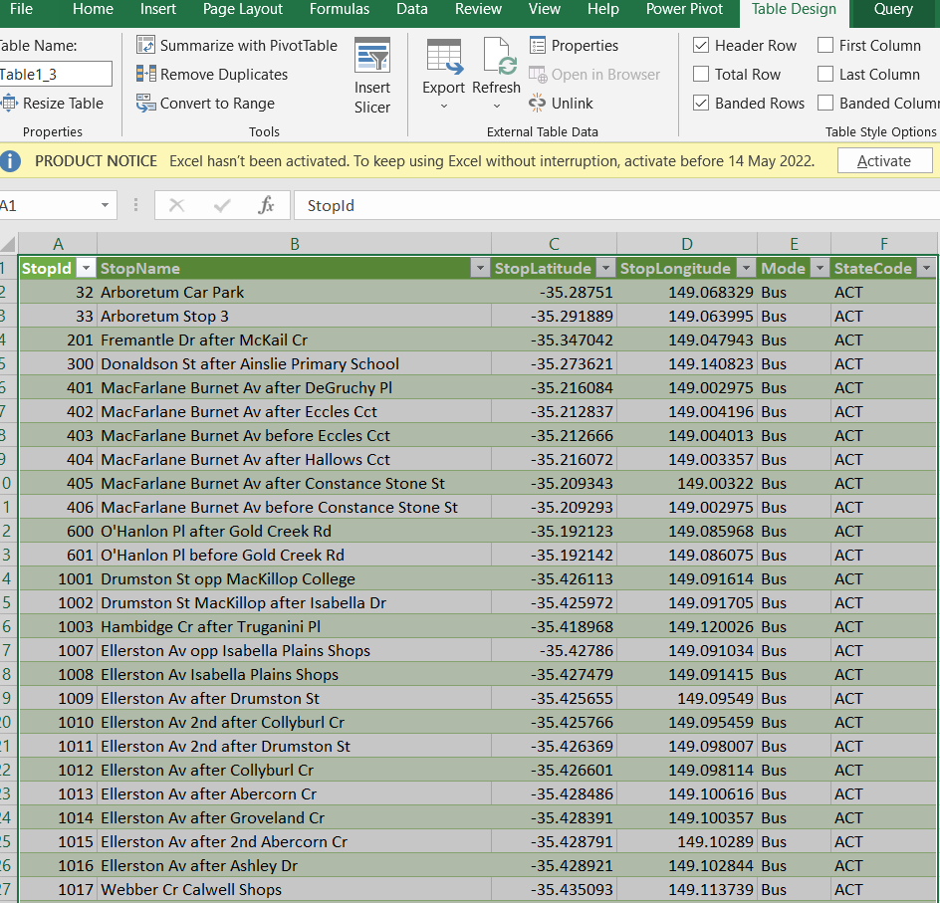

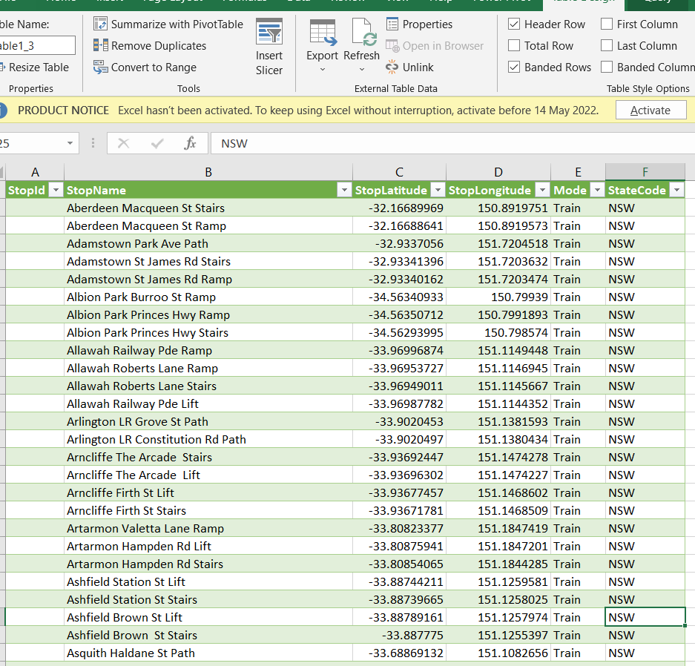

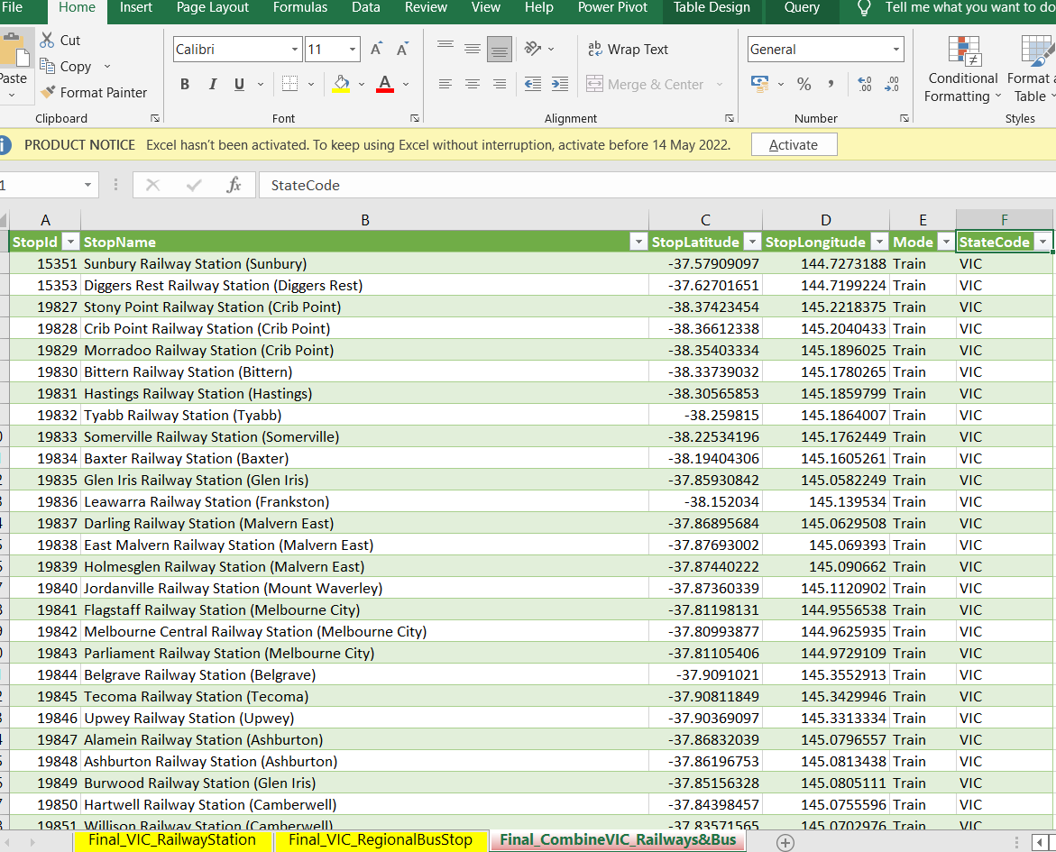

**Dataset standardised for all available States. Files listed below: -**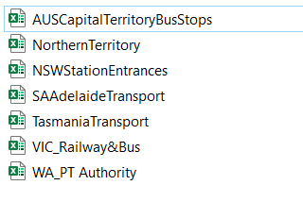

**3.Standardised datasets for Local School: -**

Dataset standardised for ACT, QLD, NSW, SA and VIC as below in one file. Snapshot of school dataset is shown below: -

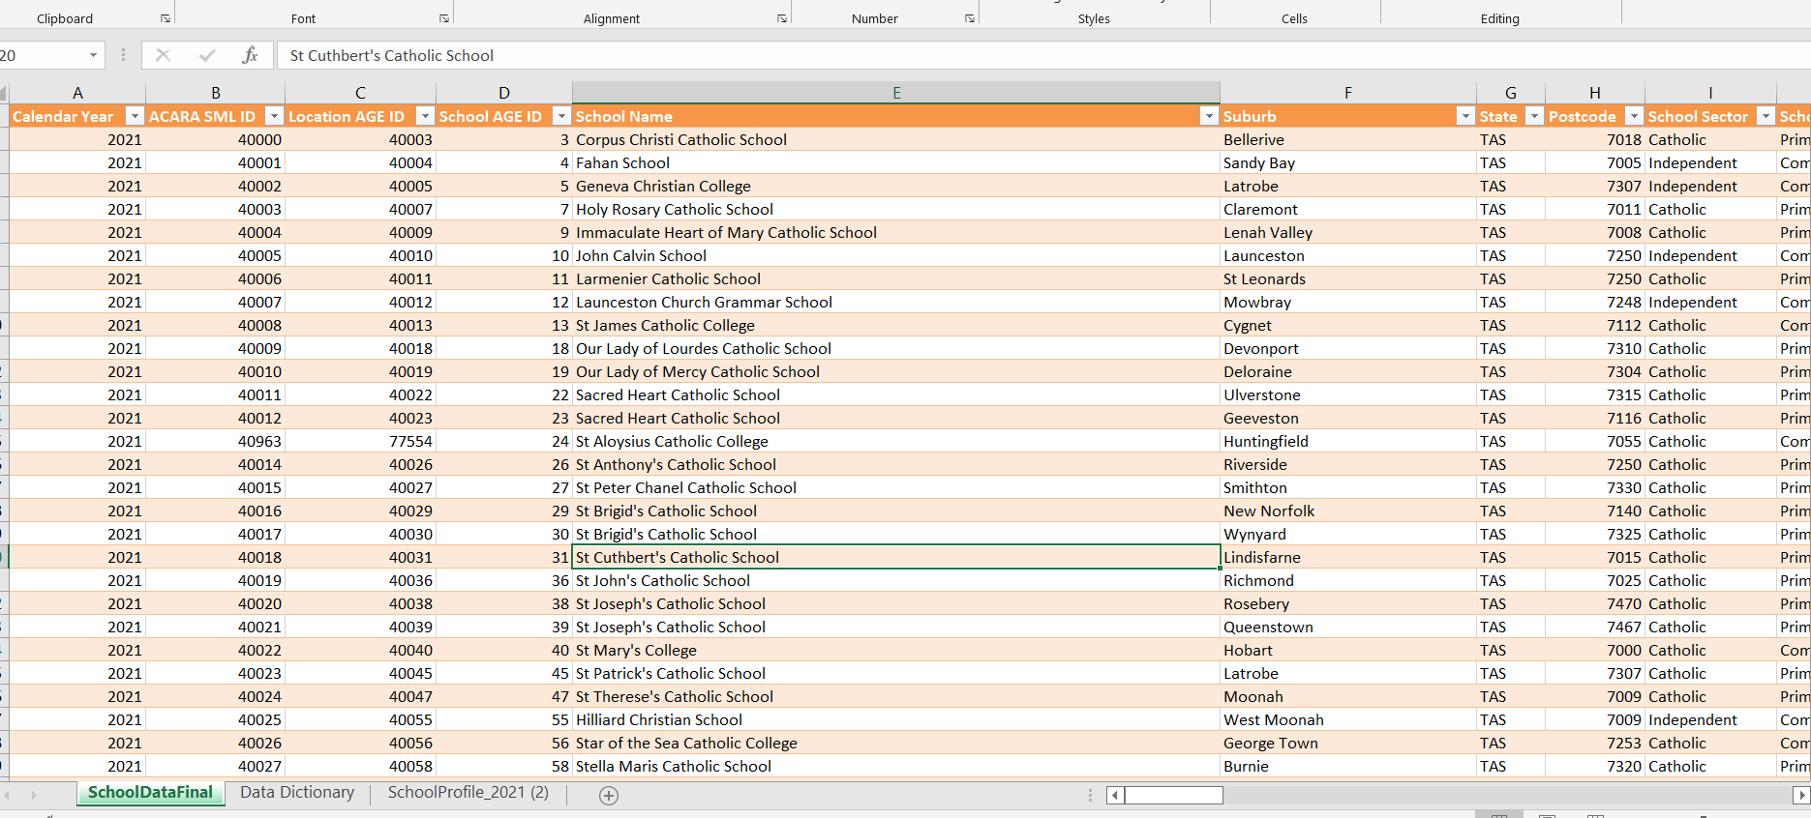

**4.Given raw dataset, standardize dataset for Rental Median per Suburb, City: -**

Dataset standardised for NSW, QLD, SA, NT and VIC. Below snapshot of VIC data shown

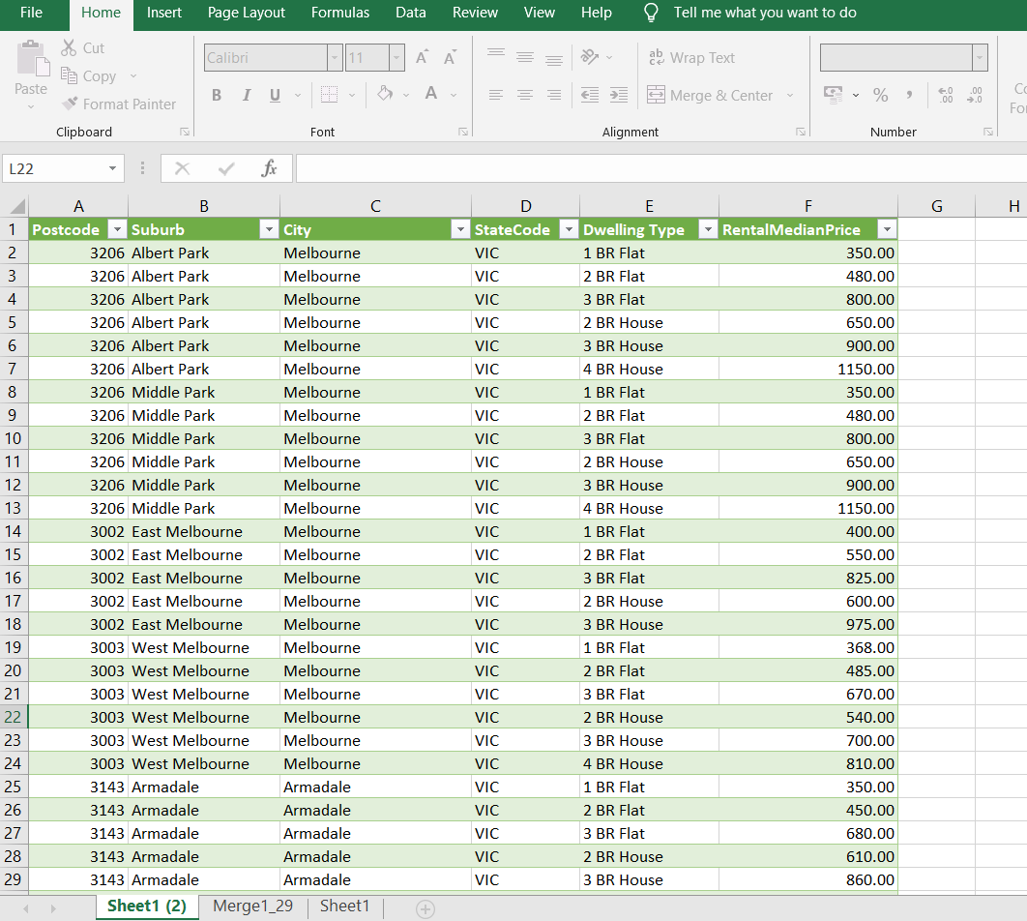

**5. Given raw dataset, , standardize the dataset for Median Property Value per Suburb**

Standardised datasets for NSW, VIC, SA, ACT, NT and WA. Snapshot of SA data shown below

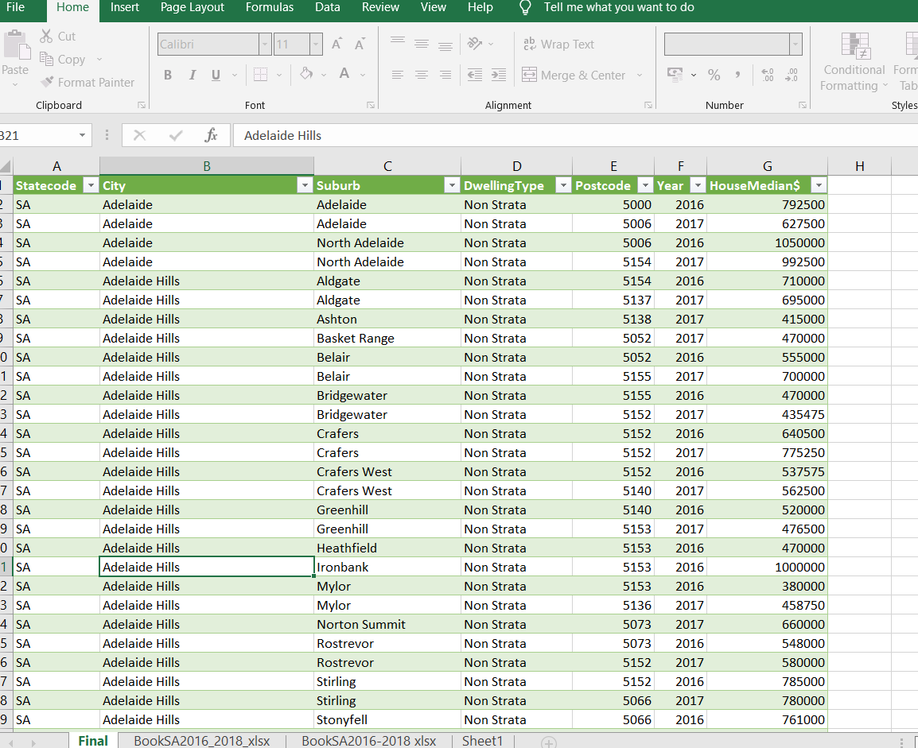

**6. Given raw dataset, standardize the dataset for crime rate of each suburb and city in OZ: -** Standardised datasets for ACT , NSW, VIC, SA, QLD , NT and WA. Snapshot of ACT data shown below

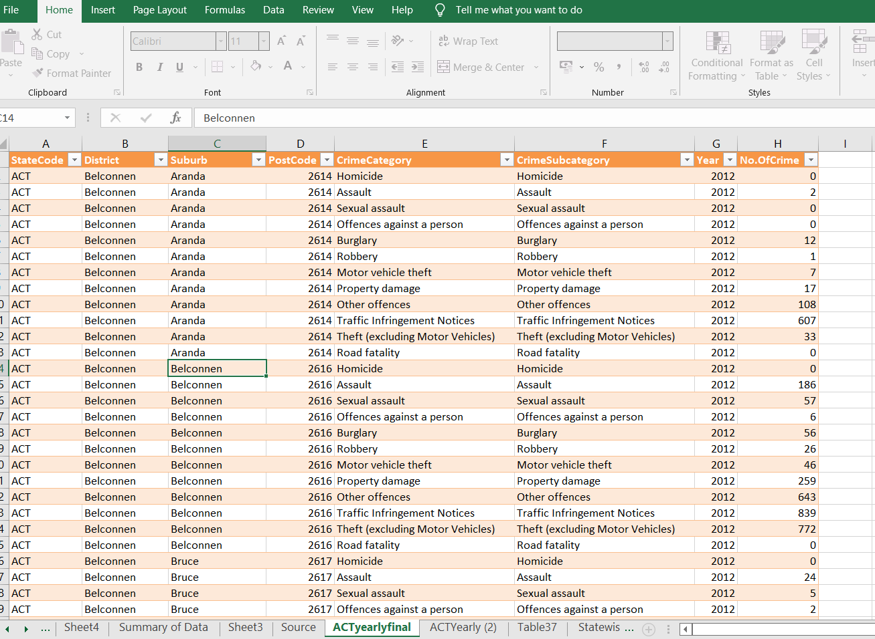

**Dataset standardised for all available States. Files listed below: -**

